Azure AirFLow Capstone Exercise -1

--- Sureshkrishna B

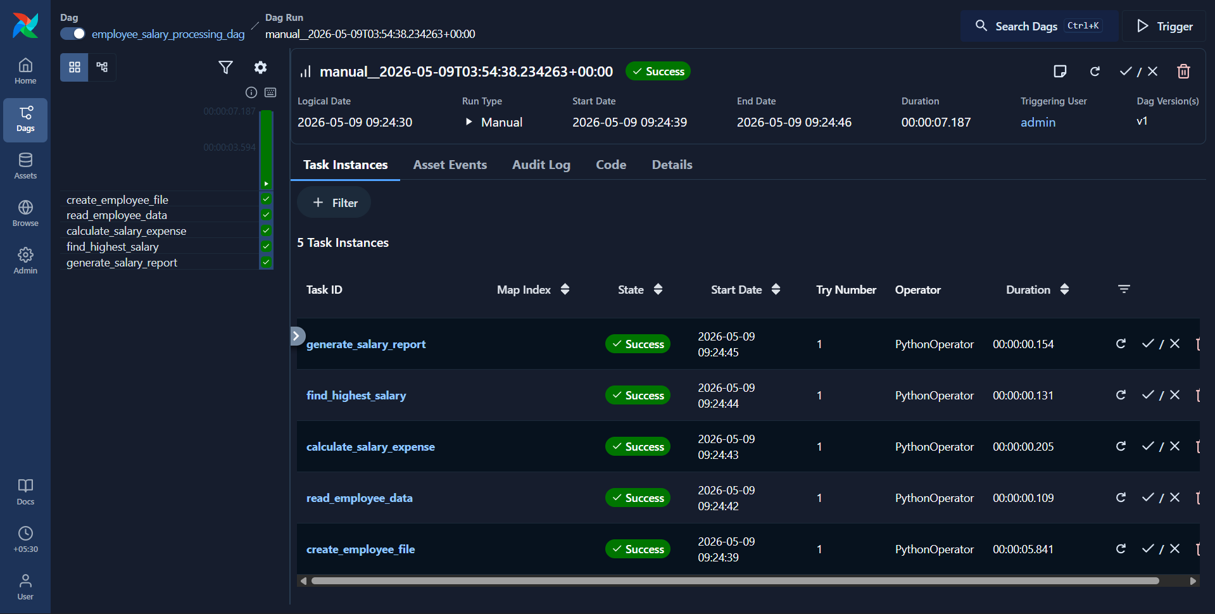

Code :
from airflow import DAG
from airflow.operators.python import PythonOperator
from datetime import datetime
def create_employee_file():
data = """Rahul,45000
Sneha,52000
Amit,61000
Priya,47000
Kiran,39000"""
with open('/tmp/employees.txt', 'w') as file:
file.write(data)
print("Employee file created successfully")
def read_employee_data():
with open('/tmp/employees.txt', 'r') as file:
data = file.readlines()
print("Employee Records:")
for line in data:
print(line.strip())
def calculate_salary_expense(ti):
total_salary = 0
with open('/tmp/employees.txt', 'r') as file:
data = file.readlines()
for line in data:
name, salary = line.strip().split(',')
total_salary += int(salary)
print(f"Total Salary Expense = {total_salary}")
ti.xcom_push(key='total_salary', value=total_salary)
def find_highest_salary():
highest_salary = 0
employee_name = ""
with open('/tmp/employees.txt', 'r') as file:
data = file.readlines()
for line in data:
name, salary = line.strip().split(',')
if int(salary) > highest_salary:
highest_salary = int(salary)
employee_name = name
print(f"Highest Salary = {highest_salary}")
print(f"Employee = {employee_name}")
def generate_salary_report(ti):
total_salary = ti.xcom_pull(
key='total_salary',
task_ids='calculate_salary_expense'
)
report = f"""Employee Salary Report
Total Employees = 5
Total Salary Expense = {total_salary}
Status = Processed Successfully
"""
with open('/tmp/salary_report.txt', 'w') as file:
file.write(report)
print("Salary report generated successfully")
default_args = {
'owner': 'airflow'
}
dag = DAG(
dag_id='employee_salary_processing_dag',
default_args=default_args,
start_date=datetime(2025, 1, 1),
schedule=None,
catchup=False
)
task1 = PythonOperator(
task_id='create_employee_file',
python_callable=create_employee_file,
dag=dag
)
task2 = PythonOperator(
task_id='read_employee_data',
python_callable=read_employee_data,
dag=dag
)
task3 = PythonOperator(
task_id='calculate_salary_expense',
python_callable=calculate_salary_expense,
dag=dag
)
task4 = PythonOperator(
task_id='find_highest_salary',
python_callable=find_highest_salary,
dag=dag
)
task5 = PythonOperator(
task_id='generate_salary_report',
python_callable=generate_salary_report,
dag=dag
)
task1 >> task2 >> task3 >> task4 >> task5

